SOA Project

Hatnean Maria Cristina

Group 258-1

This application was developed as an online ticket store, which sells tickets to different concerts and offers information about these events. It was designed to be used by people interested in buying tickets to different concerts, or simply viewing more details about them online.

It displays a list of concerts for which the user can see details and buy a ticket. In order to buy a ticket, the user has to be logged in, while only viewing the concerts does not require a log in. The application simulates sending an email with the invoice to the user, after buying a ticket. So, to sum up, an user can log in, view the list of concerts, view details about a concert and buy a ticket to that concert. The email with the received invoice is currently simulated as a console message with the contents of the invoice.

The backend consists of six microservices, each of them having a different role. There is an authentication service (authservice), a load balancer using ngnix, a service for retrieving the concerts (concerts-service), a service for generating tickets (tickets-service), one for generating the invoices (invoices-service) and one for simulating sending the emails (email-service). The load balancer distributes requests between authservice, concerts-service and tickets-service. The tickets-service communicates with invoices-service through a kafka queue, and the invoices-service communicates with the email-service through a RabbitMQ queue.

An overview of the app services in the backend can be seen in the diagram below:

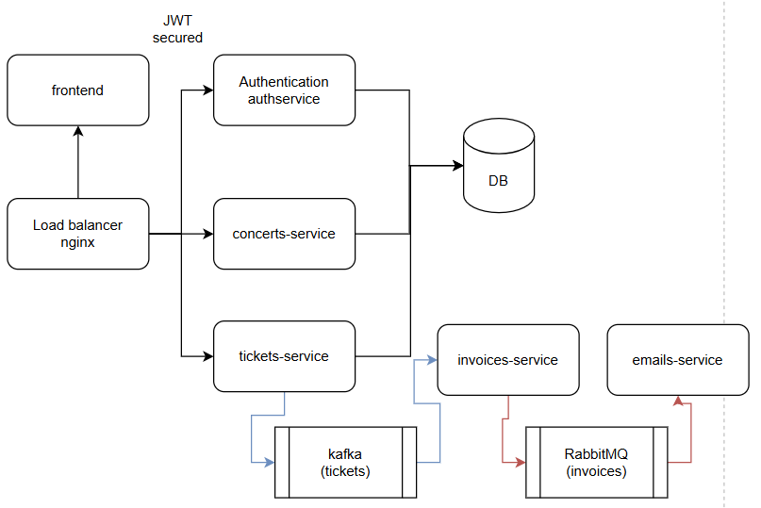

The frontend is a separate microservice, that exposes pages for login, viewing the concerts, viewing the details to a concert and buying a ticket.

The application uses Docker for creating the images and deploying the containers.

UML Diagram of frontend package:

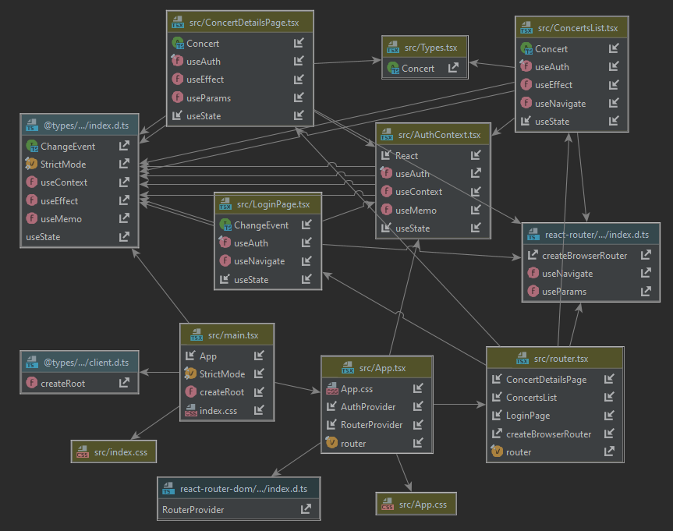

c4 Context Diagram:

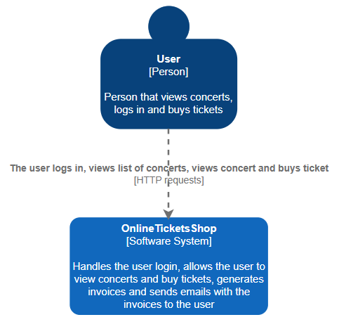

c4 Container Diagram:

